Practical lesson 5 : Physiology of microorganisms. Metabolism and nutrition of microbes. Nutrient media. Effect of physical and chemical factors on microorganisms. Sterilization and disinfection. Respiration and reproduction of microorganisms. Cultivation of aerobic and anaerobic bacteria. Bacteriological method. Isolation of pure cultures of aerobic and anaerobic bacteria (I day, II day, III day), their identification on the basis of cultural properties and enzymatic activity. Modern methods of identification of microorganisms.
The physiology of microorganisms studies their metabolism, nutrition, respiration, growth and multiplication, and, in general, all vital processes.
Chemical composition of microorganisms
The bacterial cell has the same general chemical pattern as the cells of other organisms. The bacterial cell contains water (70-80% of total weight), proteins, polysaccharides, lipids, nucleic acids, mucopeptides and low molecular weight compounds.
For growth and nutrition of bacteria, the minimum nutritional requirements are water, a source of carbon, a source of nitrogen and some inorganic salts. Water is the vehicle of entry of all nutrients into the cell and for the elimination of waste products.
Water. Protoplasm is from 80-85% water. The water in a single celled organism is continuous with the water of its environment and the molecules pass freely in and out of the cell, providing a vehicle for nutrients, inward and secretions or excretions, outward. All the enzymatically controlled chemical reactions that occur within the cell occur only in the presence of an adequate amount of water.
Minerals. All organisms require several metallic elements such as sodium, potassium, calcium, magnesium, manganese, iron, zinc, copper, phosphorous and cobalt for normal growth. Bacteria are no exception. The amounts required are very small.
The microbe cell utilizes nutrient substrates for the synthesis of its component parts, for storage as reserve material, for the synthesis of enzymes, pigments, vitamins, toxins, and also for obtaining energy needed for its existence.
Nitrogen. Although autortophic organisms can utilize inorganic sources of nitrogen, the heterotrophs get their nitrogen from amino acids and intermediate protein compounds such as peptides, and peptones. Beef extract and peptone, as used in nutrient broth provide the nitrogen needs for the heterotrophs grown on this medium.
All bacteria can be divided into two groups according to their type of nutrition: Autotrophic, Heterotrophic
Autotrophic (autos-self, trophe-nutrition).Which are able to produce organic substances from inorganic compounds (carbon dioxide). Autotroph- does not require organic compounds because it can synthesize them from inorganic compounds.
Chemosynthetic from them – obtain energy by oxidation sulfur and nitrogen inorganic compounds.
Photosynthetic – receive energy (ATP formation) during processes photosynthesis using energy of light – it is a cyclic phosphorylation by biochemical nature.
Heterotrophic (heteros – another) bacteria require organic carbon (sugars, amino acids etc.) and other substances (inorganic, trace elements, vitamins) for synthesis and receiving energy. All pathogenic bacteria are heterotrophic. Those bacteria can be subdivided into:
- Saprophytes which live at the expense of organic substances found in the surrounding environment and
- Parasites which living on or in another body, and feeding at its expense.

Types and mechanisms of bacteria metabolism

During Metabolism 2 opposite and at the same time indivisible processes occur: energy and constructive metabolism.
1. Catabolism - energy metabolism - processes of breakdown of nutrient substances with release of products and energy-rich compounds (Adenosine triphosphate (ATP)).
Fermentation: Glycolysis is a pathway of central metabolism that converts a molecule of glucose into 2 molecules of pyruvate and gives 2 ATP and 2 molecules of NADH During Fermentation - take place formation of ATP without electron transfer process and synthesis of specific metabolic end products which can be used for bacterial identification;
homofermentation - one end product, heterofermentation - several.
Aerobic Respiratory conversion: Tricarboxylic acid cycle (TCA) converts pyruvate into CO2 and gives 36 ATP molecules (formation during electron transfer and O2 reduction). Energy metabolism serves for the conversion of energy to a form in which it may be utilized by the cell which is used for building up the cell.
2. Anabolism - processes of synthesis of cellular constituents requiring energy. Constructive metabolism proceeds with the absorption of free energy.
Two processes (catabolism and anabolism) cannot be separated and are in fact interconnected. Metabolism is carried out with the help of enzymes.
Different types of nutrition are distinguished in microorganisms due to their absorption of carbon and nitrogen. According to the properties of carbon uptake, microorganisms are divided into two types - autotrophs and heterotrophs . Autotrophs (Greek, autos - self, trophe - nutrition) can use simple inorganic compounds - mainly carbon dioxide and other inorganic carbon compounds - to synthesize all complex organic substances containing carbon. Many bacteria that live in the soil (nitriding, serobacteria (Thiobacteria), etc.) belong to autotrophs. Depending on the use of the energy source - photoautotrophs that use light and chemoautotrophs that use organic compounds are distinguished . Heterotrophs (Greek, heteros - other, trophe - nutrition) use organic matter as a source of carbon . They assimilate carbon from carbohydrates (mainly glucose), amino acids and other organic compounds . Depending on the use of the energy source - photoheterotrophs using light and chemoheterotrophs using organic compounds are distinguished. Currently, the terms autotroph and heterotroph are replaced by the new terms organotroph and lithotroph, respectively. Lithotrophs are so named because they can grow in a pure mineral environment.
Aminoautotrophs - use either atmospheric nitrogen or ammonium salts as nitrogen sources for protein synthesis.
Aminoheterotrophs - use organic matter - amino acids and proteins as nitrogen sources. All pathogenic and most saprophytic microorganisms belong to this group.
Prototrophs are microorganisms capable of synthesizing all the substances they need using only glucose as a carbon source and ammonium salts as a nitrogen source. Auxotrophic microorganisms cannot synthesize any substance from glucose and ammonium salts, respectively, as a single source of carbon and nitrogen. Growth factors are required for their development.
Saprophytes (Greek sapros - decay, phyton - plant) receive ready-made organic substances from dead organisms.
Parasites (Greek: parasitos - omnivores, live at someone else's expense) take organic matter from living plants, animals and human organisms. Obligate and facultative parasites are distinguished. Obligate parasites are adapted to live inside the cell. For example, rickettsia and chlamydia, etc.

Nutritional mechanisms of microorganisms
Nutrients can enter a microbial cell in several ways:
Passive diffusion- Simple diffusion (due to the difference in osmotic pressures) - Facilitated diffusion (carrier proteins - permeases)
Active transport - Ion transport (uniport, simport, antiport) - ATF-transport Transport by translocation mechanism
Microbial enzymes and their role in metabolism
§ Endoenzymes act within the cell, and exoenzymes are secreted from the microbial cell, breaking down the macromolecules there and making it easier for them to enter the cell.
§ Constitutional and inductive enzymes
§ Metabolic enzymes - oxyreductases, transferases, lyases, ligases, hydrolases and isomerases
§ Aggression or pathogenic enzymes - hyaluronidase, neuraminidase, lecithinase, etc.
Metabolism consists of two opposite processes - catabolism and anabolism. Catabolism is the process of breaking down large molecules into smaller molecules by releasing energy. As a result, the released energy is stored in the form of macroenergetic bonds in the molecules of adenosine triphosphate (ATF) and is used for vital processes. Therefore, catabolism is sometimes called energy metabolism. In the process of anabolism, molecular compounds used to build a cell are synthesized, so it is sometimes called constructive metabolism. This process involves the consumption of energy, which uses the energy released as a result of energy metabolism.
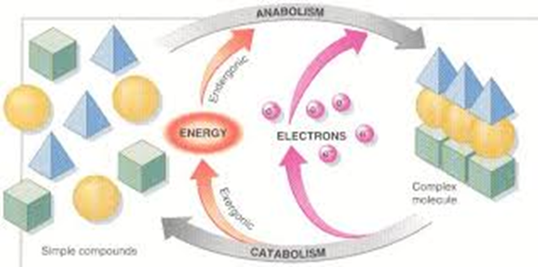

Energy metabolism (biological oxidation)
There are two types of biological oxidation (energy metabolism), depending on they are oxygenated or oxygen-free: brodil (fermentation) metabolism , oxidative metabolism
Brodil metabolism : During brodil metabolism, ATF is synthesized as a result of phosphorylation of substrates. In this case, the decomposing substrate acts as a donor of electrons, and the acceptors of the electrons are reduced, as a result of which the released energy is used for the synthesis of ATF. The process of breaking down nitrogen-free organic compounds under anaerobic conditions is called fermentation. The fermentation process consists of two stages. In the first stage, glucose is oxidized to pyruvic acid. The process of formation of pyruvic acid from glucose consists of a series of biochemical reactions. In both brodil and oxidative metabolism, this process can proceed in the same way - in three ways.
Glycolysis pathway (Embden-Meyerhof pathway) predominates in bacteria . In this case, glucose is first converted to fructose-6- phosphate, and then to pyruvic acid. During glycolysis, 2 molecules of ATF are used in the process of glucose breakdown, and 4 molecules of ATF are synthesized. Thus, 2 molecules of ATF are synthesized from 1 molecule of glucose. As a result of the reactions, phosphate is transferred from intermediate substrates to the molecule adenosine diphosphate (ADF), and thus ATF is synthesized. Therefore, it is called substrate phosphorylation.

Types of fermentation : The resulting pyruvic acid undergoes various transformations in anaerobic microorganisms, resulting in different types of fermentation, depending on the final organic matter formed.
§ Lactic acid fermentation § Alcohol fermentation § Propionic acid fermentation § Formic acid fermentation § Butyric acid fermentation
Formic acid fermentation : This fermentation is mainly characteristic of bacteria of the family Enterobacteriaceae. Many bacteria break down formic acid, which is formed during fermentation, into gas (H2 and CO2). Thus, some bacteria break down carbohydrates only to form acids, while others break them down to form both acids and gases. It is used in the biochemical identification of bacteria (use of the Hiss medium).
Butyric acid fermentation: The main products of butyric acid fermentation are butyric acids, as well as other organic acids - acetic, capron, valerian, palmitic acids, as well as butanol, acetone, isopropanol, CO2 and H2. Determination of formed acids by gas-liquid chromatography is used as an express method in the identification of obligate anaerobes. This type of fermentation is characteristic of bacteria of the genus Clostridium.
Oxidative metabolism : During oxidative metabolism, ATF is synthesized as a result of oxidative phosphorylation. In this case, pyruvic acid is completely oxidized to CO2 in the circulation of tricarboxylic acids: pyruvic acid NAD, FAD, etc. With the help of coenzymes, acetyl is converted to coenzyme A (activated acetic acid) and joined to the triacetic acid cycle (Crebs cycle).
Tricarboxylic acid cycle (Crebs cycle) : In the tricarboxylic acid cycle, acetyl groups decompose to form CO2 and 4 pairs of hydrogen atoms. Hydrogen atoms combine with NAD, NADF and FAD to reduce them to NADH2, NADFH2 and FADH2. In this way, hydrogen atoms are transferred to molecular oxygen along the respiratory chain located in the cytoplasmic membrane of microorganisms. The transfer of hydrogen atoms along the respiratory chain to molecular oxygen is provided by dehydrogenase, quinones (ubiquinone, etc.) and cytochromes.
Respiratory chain during oxidative metabolism or respiration (oxidative phosphorylation), electron donors are organic and inorganic substances, and acceptors are only oxygen. In this case, the respiratory chain:
NAD FAD cytochromes O2

Respiration of microorganisms
Microorganisms are divided into 3 main groups according to the type of respiration:
§ obligate aerobes - Microaerophiles - Capnophiles
§ obligate anaerobe - obligate anaerobes - aerotolerant anaerobes
§ facultative anaerobes

Growth and multiplication of microorganisms
As microorganisms mature, they begin to multiply .Multiplication in different microorganisms occurs in different ways . Bacteria multiply by simple, binary division. The division of a bacterial cell begins with the formation of a transverse partition. The transverse partition is provided by mesosomes.
Bacteria multiply very rapidly. The concept of generation time is used to estimate the rate of multiplication. This period represents the time required for the bacterial cell to double. Generation time is different for each type of bacteria. Bacteria, and in general all microorganisms, multiply more rapidly under optimal conditions. Most bacteria divide every 15-30 minutes. Some bacteria, such as mycobacterium tuberculosis, divide relatively late (every 20-24 hours). As the bacterial cell multiplies by dividing in two, their number increases in the culture in a geometric sequence: 2 0 – 2 1 – 2 2 - 2 3 …. 2 n , so after dividing by n, the number of bacteria in a bacterial family will be 2 n . When growing under such conditions, bacteria multiply until the components needed for their development reach a minimum, after which their proliferation stops. If no nutrients are added during this period and the metabolic products are not removed, a periodic or static culture is obtained.
Phases of bacterial multiplication in periodic culture. Periodic culture behaves as if it were a multicellular organism. The multiplication of bacteria here is subject to a certain pattern and consists of several phases. The graphical description of these phases is called the development curve.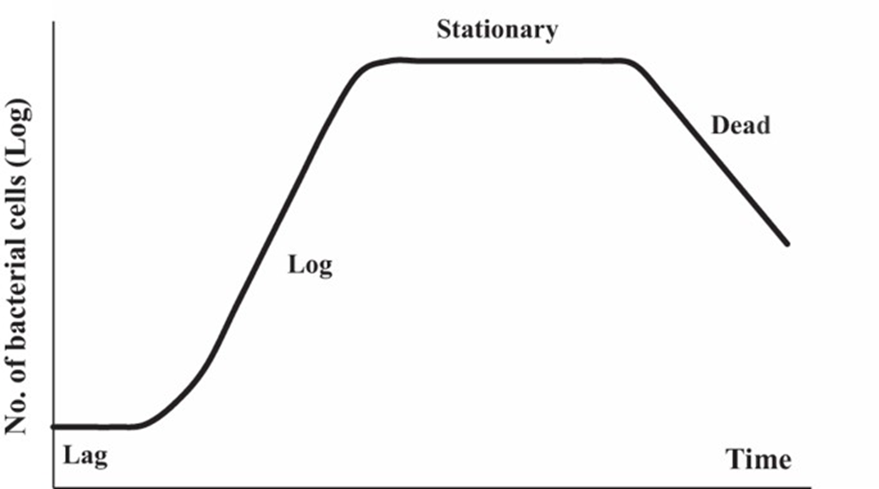

In biotechnology, conditions are created that require bacterial cells to remain in the exponential (logarithmic) phase for a long time. For this purpose, a new nutrient medium is constantly added to the culture in which the bacterial population is developing, and at the same time an appropriate amount of bacterial suspension is removed. Thus, a continuous culture is obtained. Continuous cultivation is carried out on special cultivators - chemostats and turbidostats. When cultivating in hemostats, as fresh nutrient medium is added to the cultivator, an appropriate amount of bacterial suspension is removed. Cultivation in turbidostats is based on maintaining a constant optical density of bacterial suspension in the cultivator.
A population formed by bacteria in nutrient media is called a culture .Under optimal conditions, bacteria form a unique population, which is called culture. As they grow in nutrient media, the nature of the cultures produced by each bacterial species is different. It is used in the identification of bacteria because their cultural characteristics are relatively stable.

Disinfectants and antiseptic preparations
- Surfactants - soaps and detergents (decamine, chlorhexidine, etc.)
- Phenol and its derivatives (tricresol, phenylresorcinol, phenylsalicylate)
- Oxidizers (hydrogen peroxide, potassium permanganate, etc.)
- Halogens (alcoholic solution of iodine, lugol's solution, iodoform, iodinol), chlorine (chlorinated lime, chloramines, pantoside)
- Alcohols (ethyl alcohol, etc.)
- Acids, their salts (boric, salicylic, benzoic, acetic acids) and alkalis (ammonia and its salts, zinc);
- Aldehydes (formaldehyde and its 40% solution - formalin, hexamethylenetetramine - urotropin, glutar aldehyde, etc.)
- Heavy metal salts (mercury dichloride, silver nitrate, copper sulfate, etc.).
- Dyes (diamond green, methylene blue, ethacridine lactate - rivanol, etc.)
Effect of chemical factors on microorganisms
- Disinfection is the destruction of pathogenic microorganisms in the environment.
- Chemicals used for this purpose are called disinfectants.
- Substances that do not have a harmful effect on the human body are used to remove microorganisms from the skin and mucous membranes, wounds. In such cases, these substances are called antiseptics and are used for antiseptic purposes.
- A set of measures applied to remove microorganisms from different parts of the human body, as well as from wounds, is called antiseptic.
- Asepsis is a set of measures taken to prevent contamination of various objects (various areas of the body, skin and mucous membranes, including wounds) with microorganisms.
Sterilization
- It is the complete destruction of microorganisms, as well as their spores, in various objects.
- Sterilization is carried out in different ways:
- Physical methods (under the influence of high temperatures and various rays);
- Chemical methods (under the influence of various disinfectants and antiseptics, as well as antibiotics);
- Mechanical methods (application of bacterial filters)
Physical sterilization (thermal sterilization)
- Burning and boiling sterilization is one of the simplest and most convenient methods of heat sterilization
- Dry heat and high pressure saturated water vapor are mainly used for thermal sterilization.
- Dry hot sterilization is carried out in pasteurization furnaces (air sterilizers). The most common mode is sterilization at 165-170⁰C for 1 hour, in which case all microorganisms, as well as their spores are completely destroyed.
- High pressure saturated water vapor is used to sterilize materials that change their properties and quality at high temperatures. Autoclaves (steam sterilizers) are used for this purpose. The most common mode of operation is sterilization at 2 atm at 121⁰C for 30 minutes, in which case all microorganisms, as well as their spores, are completely destroyed.
- Pasteurization can be considered conventional sterilization. 1-hour exposure at 65⁰-70⁰C allows to destroy vegetative forms of microorganisms in food (milk, wine, beer, fruit juices, etc.).
Physical sterilization (radiation sterilization)
- It is used for sterilization of thermolabile materials.
- The sterilizing effect of ultraviolet rays is limited by its low permeability and high absorption when passing through water and glass.
- Although gamma and X-rays have effective sterilizing properties, their application requires strict adherence to safety regulations. Biological preparations (serum, vaccines, etc.), disposable syringes, petri dishes, surgical sutures are sterilized by these rays.
- In some cases, microwave radiation and ultrasound are also used for sterilization.
Mechanical sterilization
- Sterilization by filtration through bacterial filters is used for sterilization of thermolabile liquid solutions.
- In microbiological practice are widely used Zeitz filters made from a mixture of asbestos and cellulose, membrane filters made from nitrocellulose, Chamberlain and Berkfeld filters made from a mixture of kaolin sand and quartz.
- Filters allow to get release from most microorganisms and sometimes viruses protein-rich media, blood serum and various drugs
Chemical sterilization
- Antimicrobials, disinfectants and antiseptics, as well as selective antibiotics and synthetic antimicrobials are used for chemical sterilization for the destruction of all microorganisms (see below).
- In some cases, toxic gases, such as ethylene oxide, are used for this purpose.
Quality control of sterilization
- Chemical control - substances with known melting point are used (sulfur - 119⁰ C, benzoic acid - 120-122⁰ C, benzonaftol - 110⁰ C, mannose and urea - 132-133⁰ C), as well as temperature indicator papers. Judgments are made based on changes in these ingredients, which are placed in an autoclave along with the materials to be sterilized.
- Biological control - biotests (paper boards or strips with heat-resistant spore bacteria on the surface). These paper strips, which are placed in the autoclave along with the materials to be sterilized, are judged on the basis of whether the spore bacteria are destroyed.

